$$c++ LOOPS$$

**ASSIGNMENT**

CB.EN.U4CSE19063

1. Write a program in C++ to find the first 10 natural numbers

#include <iostream>

#include <cstdio>

#include <cmath>

using namespace std;

class natural

{

public :

int n,i;

public:

void naturalno()

{

for (i = 1;i <=10;i++)

{

cout << i;

}

}

};

int main()

{

natural n1;

n1.naturalno();

}



2. Write a program in C++ to find the sum of first 10 natural numbers

#include <iostream>

#include <cstdio>

#include <cmath>

using namespace std;

class natural

{

public :

int n;

public:

void naturalsum()

{

int i = 0;

int sum=0;

cout << "please enter how many numbers to find sum of : ";

cin >> n;

for (i = 0;i < n;i++)

{

sum = sum + i ;

}

cout << "The sum of " << n << " numbers is : " << sum;

}

};

int main()

{

natural n1;

n1.naturalsum();

}

Screenshot (221).png

3. Write a program in C++ to display n terms of natural number and their sum.

#include <iostream>

#include <cstdio>

#include <cmath>

using namespace std;

class natural

{

public :

int n;

public:

void naturalno()

{

int i = 0;

cout << "please enter how many numbers to print : ";

cin >> n;

for (i = 0;i <=n;i++)

{

cout << "\n" << i+1;

}

}

public:

void naturalsum()

{

int i;

int sum=0;

for (i = 1;i <=n;i++)

{

sum = sum + i ;

}

cout << "The sum of " << n << " numbers is : " << sum;

}

};

int main()

{

natural n1;

n1.naturalno();

n1.naturalsum();

}

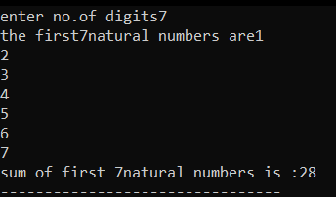

4) perfect numbers between 1 and 500

#include <iostream>

#include <cmath>

using namespace std;

class perfect_number

{

public:

void perfectno()

{

int i,j,sum = 0;

for(i = 1;i < 500;i++)

{

sum = 0;

for(j = 1;j < i;j++)

{

if (i % j == 0)

{

sum = sum + j;

}

}

if (sum == i)

{

cout << "\n" << i;

}

}

}

};

int main()

{

perfect_number p1;

p1.perfectno();

}

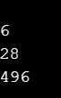

5) Write a program in C++ to check whether a number is prime or not.

#include<iostream>

using namespace std;

int main()

{

int i,j,div,a,b,count,sum;

cout<<"\n enter the number ";

cin>>b;

for(i=b;i<=b;i++)

{ int sum=0;

for(j=1;j<=i;j++)

{

div = i % j;

if (div == 0){

sum = sum + 1;

}

}

if(sum==2){

cout<<"a prime number";

}

else{

cout<<"not a prime number";

}

}

return 0;

}

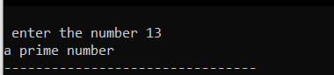

6) Write a program in C++ to find prime number within a range.

#include<iostream>

using namespace std;

int main()

{

int i,j,div,a,b,count;

cout<<"enter the starting range : ";

cin>>a;

cout<<"\n enter the ending range : ";

cin>>b;

for(i=a;i<=b;i++)

{ int sum=0;

for(j=1;j<=i;j++)

{

div = i % j;

if (div == 0){

sum = sum + 1;

}

}

if (sum == 2)

{

cout << i<<" " ;

count=count+1;

}

}

cout<<"\nthe total no.of prime numbers between "<<a<<" to "<<b<<" is :"<<count;

return 0;

}

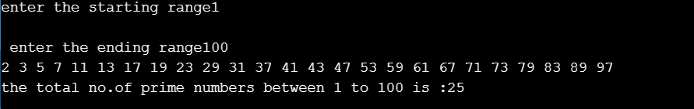

7) Factorial of a num?

#include <iostream>

#include <cmath>

#include <cstdio>

using namespace std;

class factorial {

public:

int n,fac,i;

public:

void fact()

{

fac = 1;

cout << " enter the number to be a : ";

cin >> n;

for(i = n; i >= 1; i--)

{

fac = fac * i;

}

cout << " factorial of the given num is = " << fac << endl;

}

};

int main()

{

factorial f1;

f1.fact();

}

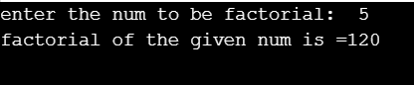

8) Write a program in C++ to find the last prime number occur before the entered number.

#include <iostream>

#include <cmath>

#include <cstdio>

using namespace std;

class rprime

{

public:

int n,i,j,count;

public:

void primen()

{

count = 0;

cout << " enter the num : ";

cin >> n;

for (i = n-1;i > 1; i--)

{

count = 0;

for (j = 1; j <= i;j++)

{

if (i % j == 0)

{

count = count + 1;

}

}

if (count == 2)

{

cout << I "is the prime number just before " << n ;

break;

}

}

}

};

int main()

{

rprime p1;

p1.primen();

}



9) Write a program in C++ to find the sum of the series 1 + 1/2^2 + 1/3^3 + ..+ 1/n^n.

#include <iostream>

#include <cmath>

using namespace std;

int main()

{

int n,i;

double sum;

cout << "please enter a number : ";

cin >> n;

sum = 0;

for(i = 1; i<=n; i++)

{

cout << " \n " <<"The "<< i << " th term is " << (1/pow(i,i)) ;

sum = sum + (1/pow(i,i));

}

cout << "\n sum of the series : " << sum;

}

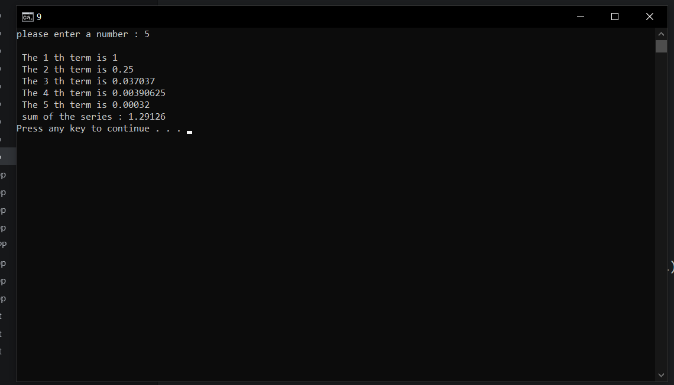

10) Write a program in C++ to calculate the sum of the series (1*1) + (2*2) + (3*3) + (4*4) + (5*5) + ... + (n*n).

#include <iostream>

#include <cmath>

using namespace std;

class series

{

public:

int n,i,sum;

public:

void ser()

{

sum = 0;

cout << "input the value for nth term : ";

cin >> n;

for(i = 1;i <= n;i++)

{

sum = sum + (i*i);

cout << " \n "<< i << "*" << i << "=" << (i*i);

}

cout << "The sum of the above series is : " << sum;

}

};

int main()

{

series s1;

s1.ser();

}

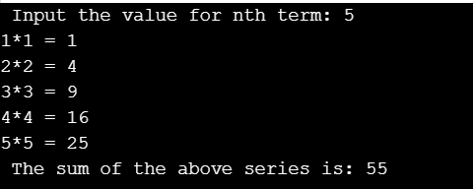

11) Write a program in C++ to find the sum of series 1 - X^2/2! + X^4/4!-.... upto nth term

#include <iostream>

#include <math.h>

using namespace std;

int main()

{

float x, sum, t, fact, y, j, m;

int i, n;

t = 1;

y = 2;

cout << " Input the value of X: ";

cin >> x;

cout << " Input the value for nth term: ";

cin >> n;

sum = 1;

cout << " term 1 value is: " << t << endl;

for (i = 1; i < n; i++)

{

fact = 1;

for (j = 1; j <= y; j++)

{

fact = fact * j;

}

t = t * (-1);

m = pow(x, y) / fact;

m = m * t;

cout << " term " << i + 1 << " value is: " << m << endl;

sum = sum + m;

y += 2;

}

cout << " The sum of the above series is: " << sum << endl;

return 0;

}

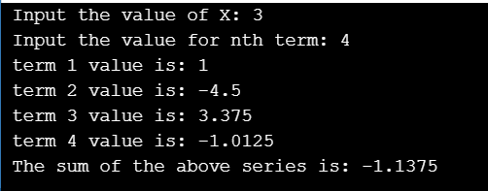

12) Write a program in C++ to display the n terms of odd natural number and their sum.

#include <iostream>

#include <cmath>

using namespace std;

int main()

{

int i,terms,sum=0;

cout << "please enter no of odd terms : ";

cin >> terms;

for (i = 1;i < 2*(terms);i+=2)

{

cout << "\n" << i;

sum = sum + i;

}

cout << "\nThe sum of first odd integers is : " << sum;

}

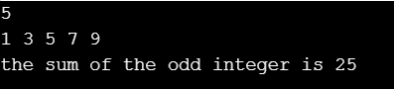

13) Write a program in C++ to display the sum of the series [ 9 + 99 + 999 + 9999 ...].

#include <iostream>

using namespace std;

int main()

{

long int n, i, k = 9;

int sum = 0;

cout << " Input number of terms: ";

cin >> n;

for (i = 1; i <= n; i++)

{

sum += k;

cout << k << " ";

k = k * 10 + 9;

}

cout << "\n The sum of the serise = " << sum << endl;

}

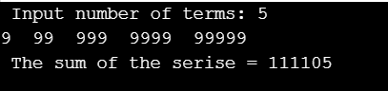

14) Write a program in C++ to find the length of a string without using the library function.

#include <iostream>

#include <string>

using namespace std;

int main()

{

char str[150];

int length = 0,i;

cout << " enter the string : ";

cin >> str;

for (i = 0; str[i] != '\0';i++)

{

length = length + 1;

}

cout << “\n”<< length;

}



15) Write a program in C++ to make such a pattern like right angle triangle using number which will repeat the number for that row

#include <iostream>

#include <cmath>

#include <cstdio>

using namespace std;

int main()

{

int i,j,n;

cout << "please enter the number of rows : ";

cin >> n;

for ( i = 1;i <= n;i++)

{

cout << "\n";

for (j = 1;j <= i;j++)

{

cout << i;

}

}

}

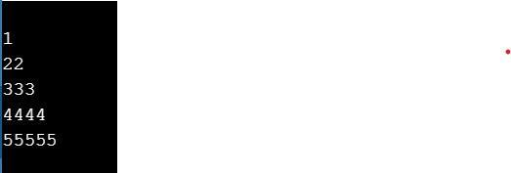

16) Write a program in C++ to make such a pattern like a pyramid with numbers increased by 1

#include <iostream>

#include <string>

using namespace std;

int main()

{

int i,j,hai,rows,k,t=1;

cout << " Input number of rows: ";

cin >> rows;

hai=rows+4-1;

for(i=1;i<=rows;i++)

{

for(k=hai;k>=1;k--)

{

cout<<" ";

}

for(j=1;j<=i;j++)

cout<<t++<<" ";

cout<<endl;

hai--;

}

}

17) Write a program in C++ to display such a pattern for n number of rows using number. Each row will contain odd numbers of number. The first and last number of each row will be 1 and middle column will be the row number. n numbers of columns will appear in 1st row.

#include <iostream>

using namespace std;

int main()

{

int i,j,n;

cout << "number of rows: ";

cin >> n;

for(i=0;i<=n;i++)

{

for(j=1;j<=n-i;j++)

cout<<" ";

for(j=1;j<=i;j++)

cout<<j;

for(j=i-1;j>=1;j--)

cout<<j;

cout<<endl;

}

}

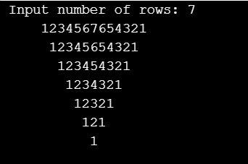

18) Write a program in C++ to find the frequency of each digit in a given integer.

#include <iostream>

using namespace std;

int main()

{

int n, i, j, ctr, r;

cout << " Input any number: ";

cin >> n;

for (i = 0; i < 10; i++)

{

cout << "The frequency of " << i << " = ";

ctr = 0;

for (j = n; j > 0; j = j / 10)

{

r = j % 10;

if (r == i)

{

ctr++;

}

}

cout << ctr << endl;

}

}

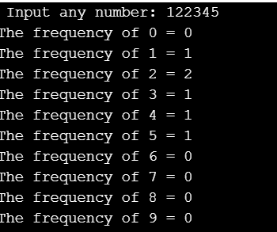

19) Write a program in C++ to find one's complement of a binary number.

#include <iostream>

using namespace std;

int main()

{

int i, SZ;

cout << " Input no.of bits: ";

cin >> SZ;

char binary[SZ + 1], onesComp[SZ + 1];

int error = 0;

cout << " Input a " << SZ << " bit binary value: ";

cin >> binary;

for (i = 0; i < SZ; i++)

{

if (binary[i] == '1')

{

onesComp[i] = '0';

}

else if (binary[i] == '0')

{

onesComp[i] = '1';

}

else

{

cout << " Invalid Input. Binary number consists only 1's and 0's" << endl;

error = 1;

break;

}

}

onesComp[SZ] = '\0';

if (error == 0)

{

cout << " The original binary = " << binary << endl;

cout << " Ones complement the number = " << onesComp << endl;

}

}

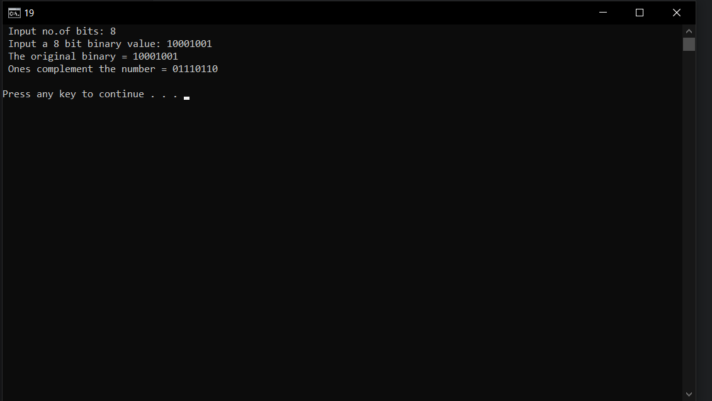

20) Write a program in C++ to compute the sum of the digits of an integer.

#include <iostream>

using namespace std;

int main()

{

int n,sum=0,m;

cout << " Enter a number: ";

cin >> n;

while (n > 0)

{

m = n % 10;

sum = sum + m;

n = n / 10;

}

cout << " Sum of digits = "<<sum<<endl;

return 0;

}

